5.120: a) There are many ways to do these sorts of problems; the method presented is fairly straightforward in terms of application of Newton’s laws, but involves a good deal of algebra. For both parts, take the x-direction to be horizontal and positive to the right, and the y-direction to be vertical and positive upward. The normal force between the block and the wedge is n; the normal force between the wedge and the horizontal surface will not enter, as the wedge is presumed to have zero vertical acceleration. The horizontal acceleration of the wedge is A, and the components of acceleration of the block are 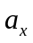 and 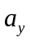. The equations of motion are then
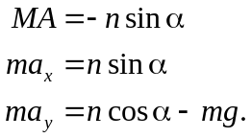
Note that the normal force gives the wedge a negative acceleration; the wedge is expected to move to the left. These are three equations in four unknowns, A, 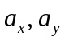 and n. Solution is possible with the imposition of the relation between A, 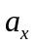 and .
An observer on the wedge is not in an inertial frame, and should not apply Newton’s laws, but the kinematic relation between the components of acceleration are not so restricted. To such an observer, the vertical acceleration of the block is 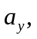 but the horizontal acceleration of the block is 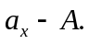 To this observer, the block descends at an
angle 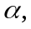 so the relation needed is
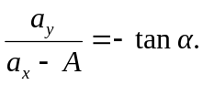
At this point, algebra is unavoidable. Symbolic-manipulation programs may save some solution time. A possible approach is to eliminate by noting that 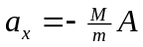 (a result that anticipates conservation of momentum), using this in the kinematic constraint to eliminate and then eliminating n. The results are:
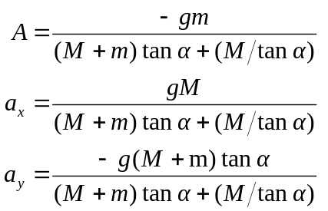
(b) When 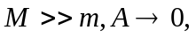 as expected (the large block won’t move). Also, 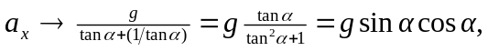which is the acceleration of the block (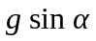in this case), with the factor of giving the horizontal component. Similarly, 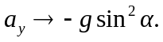
(c) The trajectory is a spiral.

